Latest Round-ups:
Season 2019/20
#17
Midweek Action: It was a busy week for county cup games, starting on Monday evening, where Calne Town moved through to the third round of the Wiltshire Senior Cup thanks to a 4-0 win away at Cricklade. Goals either side of the interval from Max Wyatt put Calne two ahead, with recent signing Keiron Gleed and Jake Allen scoring in the closing stages to complete the victory. 24 hours later in the Gloucestershire Challenge Trophy, Hallen came from behind to beat Sharpness 3-2. The visitors went ahead thanks to a wonder strike during the first half, with Hallen managing to get back on level terms five minutes before the break through Ed Bamfo. The second half belonged to Sacha Tong, with the Hallen forward scoring a pair of headers to book the home side’s passage through to the second round. Bitton also progressed in that competition, with two goals in the final 20 minutes from Josh Egan helping them overturn a one-goal deficit against ten-man Stonehouse. There was also a big 5-0 win for Roman Glass St George in their first round clash at home to Bourton Rovers, while Bristol Telephones prevailed on penalties away at Cadbury Heath. Enis Akgun struck five minutes from time for the home side to cancel out Jamie Sheppard’s opener, but the Phones showed plenty of resolve, winning 4-3 on spot kicks. In the Somerset Premier Cup, Bridgwater defeated fellow Premier Division side Keynsham 1-0, with a header from Tom Ellis three minutes before the interval proving to be the difference between the teams. In Devon, second half goals from Tom Strike and Jordan Annear helped Tavistock defeat Exeter City in the St Luke’s Challenge Cup. Exmouth Town also moved through to the third round of that competition, after a hat trick from Jordan Harris saw them ease to a 5-1 victory over Honiton.
Bradford Town set up a second round clash with Bitton in the Les Phillips Cup after surviving an early scare to defeat Brislington 4-1. Mason Dagger had given the home side a dream start, but the Bobcats were soon in front, with Jamie Lyons and Gary Higdon each heading home inside the opening 20 minutes. Tyson Pollard then tucked home a penalty on the hour mark, with Lewis Powell adding a fourth for Bradford to close out the win. In the other tie, First Division Cheddar claimed an impressive away victory at Premier Division Buckland. It was a pair of quick-fire first half goals from Aaron Hooper and Robbi Maggs, which helped to decide the contest, with Callum Ham also saving a penalty to help preserve the Cheesemen’s clean sheet.

There was also a trio of league games on Wednesday night, with the three away sides enjoying successful trips. In the First Division, Sherborne extended their winning run with a 3-0 victory away at Hengrove. The Zebras flew out of the blocks at Paprika Park, and built a two-goal lead within the opening quarter-hour thanks to goals from Sam Farthing and Anthony Herrin. The visitors are among the form teams in the division, and added to their winning margin when second half substitute Joe Smith struck soon after joining the field of play.
Plymouth Parkway took ownership of top spot in the Premier Division on Wednesday following a 2-0 win away at Wellington. With a number of cup clashes on their upcoming schedule, Parkway picked up a vital three points thanks to goals either side of the interval from Luke Mortimore and Adam Carter. In the other fixture, Street drew for the first time this season, coming from behind to secure a point away at Westbury. The Wiltshire side were handed a huge fillip in the early stages of the game, going ahead in stunning fashion when Sam Jordan rifled an unstoppable 30-yarder into the back of the Street net. The visitors fought back however, and with the first half coming to a close, recent signing Callum Thompson struck from close range to secure a 1-1 draw.
Westbury celebrate Sam Jordan’s stunner during their 1-1 draw with Street. Image courtesy of Martin Pearce.
Premier Division: Bradford Town moved back into top spot following a convincing 5-0 win away at Street. With 14 of their league fixtures now completed, the Bobcats have tasted victory 12 times, and suffered defeat only once. Their latest triumph was among their easiest of the season, with an early bundled finish from Will Hailston setting them on their way at the Tannery Ground. Gary Higdon then doubled Bradford’s tally following good play from Matt Morris, with Lewis Powell extending the lead to three thanks to another Morris assist. Higdon’s second of the afternoon came thanks to a well-placed Hailston cross, with Tyson Pollard then adding the finishing touches soon after. Bridgwater Town came out on top of an entertaining five-goal encounter away at Cribbs, with three different goalscorers helping them to victory at the Lawns. Town went ahead inside the opening ten minutes, when the two frontmen combined, with Jack Taylor flicking the ball home from Steve Murray’s pinpoint cross. Cribbs then produced an excellent spell, with Joe White providing two assists for Ed Harrison who scored in the 25th and 27th minutes to turn the game in the hosts’ favour. With the first half coming to a close, Bridgwater provided a magic five minutes of their own, with a pair of headed goals from Tom Ellis and then David O’Hare putting them 3-2 ahead.
Hallen have now won five on the bounce in all competitions, after coming from behind to defeat Westbury United 2-1. The Wiltshire side went ahead on the half-hour mark, when leading scorer Ricky Hulbert was left unmarked to convert Joe Stradling’s cross. Hallen weren’t behind for long however, and grabbed a share of the half-time spoils when Matt Davis headed home a corner. The winner was worth waiting for, and arrived in the 63rd minute when Kyle Thomas unleashed an excellent strike from 25 yards out to settle the game in Hallen’s favour. Tavistock overtook hosts Shepton Mallet in the league table after both Josh Grant and Jack Crago scored in either half to complete a comfortable 4-0 away victory. There was also a rise in the standings for Buckland Athletic, who climbed into the top half after Richard Groves’ early free-kick handed them a 1-0 win away at Keynsham Town. There was late drama at Springfield, where Clevedon Town scored an injury-time equaliser to rescue a 2-2 draw away at Cadbury Heath. Matt Huxley has been Mr. Dependable for the Heath for a couple of season’s now, and his two first half efforts saw the home side lead by two goals to one at the interval. With time running out, Clevedon looked set to suffer defeat, but they eked out one more opportunity, which Elliot Nicholson converted with a cheeky back-heel to secure a late point. Brislington also battled back to secure a 2-2 draw, with Neikell Plummer playing the starring role for them away at Roman Glass St George. Plummer did excellently to tee up Mason Dagger for Brislington’s 20th minute opener, but the visitors were stung by their in-form hosts, who struck twice to lead 2-1 at the interval. Then, with less than 30 minutes left on the clock, Plummer struck to secure the second draw in the space of 11 days between the two sides. Wellington have now lost five on the bounce, after first half goals from Alex Grimshaw and Aysa Corrick led Bitton to a two-goal victory in South Gloucestershire.
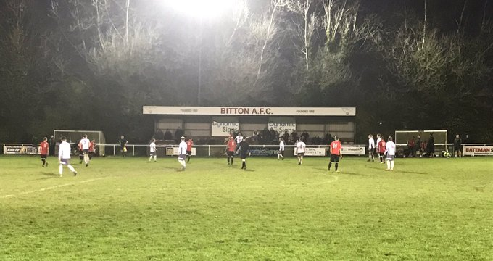
The scene at Bitton, where they defeated Wellington 2-0 on Saturday afternoon.
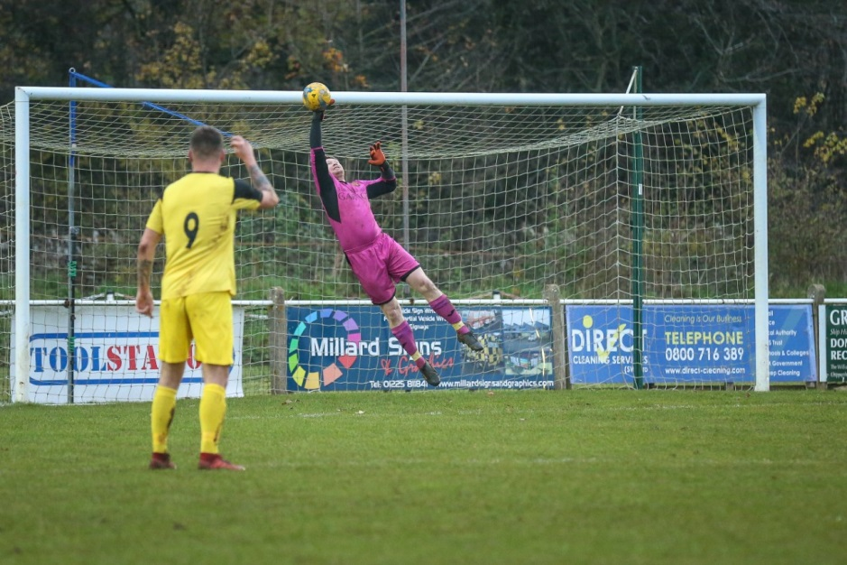
First Division: A late smash and grab from Longwell Green Sports saw them move up to second spot, scoring twice in the closing stages to defeat Devizes Town 2-1. Devizes are without a league win since the end of September, but they were on track for all three points after Charlie Buckingham had put them ahead five minutes before the interval. It was late heartbreak however for the visitors, with Liam Oswin and Tom Welling each scoring in final five minutes to hand Longwell Green all three points. Third-placed Sherborne have now won five of their last six after storming to a 5-0 victory at home to Ashton & Backwell United. Ashley Clarke and Joe Smith each scored doubles in the Zebra’s big win, with Alex Murphy maintaining his fine run with another goal at Raleigh Grove. Calne Town still continue to lead the way atop the division, with a goal in either half proving to be enough to see off the challenge of Corsham. After former Corsham-forward Jamal Chevolleau had fired the away side ahead in the 44th minute, the result was only confirmed eight minutes from time when a 35-yard belter from Nathan Davis made it 2-0 to the Lilywhites. Cheddar backed up their impressive midweek cup victory with a late 1-0 win away at Portishead Town. Having gone close on a couple of occasions during the 90 minutes, Cheddar were reliant on a stoppage time goal to snatch victory, with a low cross from Aaron Hooper converted well by Adam Jones to spark joyous scenes. Another away side who took home all three points on Saturday afternoon were Warminster, with Francois Allen and Ian Jeffery both on target during their 3-0 victory over Almondsbury. There was a third consecutive home draw for Wells City, who pegged back Welton Rovers in a 1-1 tie at the Athletic Ground. Following a goalless first half, Rovers flew out of the blocks, going ahead just 35 seconds after the restart through Liam Evans. The visitors were unable to hold on to their lead for long however, with Wells’ Harry Foster slotting home a 55th minute penalty to draw his side level. The bottom two also drew 1-1, with Dhani Golding on target for Bristol Telephones during their stalemate at Bishop Sutton.
Action from the First Division clash between Corsham and Calne at the Southbank Ground, courtesy of John Cuthbertson.
Be sure to check out the latest podcast, where Ian, Tom & guests recap all the latest news and results from around the Western League. To follow along all season, each broadcast will be available at the following link: http://www.toolstationleague.com/podcasts.php

Western League Statistical Leaders

PREMIER DIVISION LEADING GOAL SCORERS (League only):
Adam Carter (Plymouth Parkway) – 20
Lucas Vowles (Clevedon Town) – 11
Gary Higdon (Bradford Town) – 11

PREMIER DIVISION TOP ATTENDANCES:
Bridport 0 Bridgwater Town 6, Sunday 6th October 2019 – 347
Wellington 0 Exmouth Town 2, Sunday 6th October 2019 - 315
Plymouth Parkway 1 Exmouth Town 0, Wednesday 21st August 2019 - 308

FIRST DIVISION LEADING GOAL SCORERS (League only):
James Rustell (Radstock Town) – 15
Harry Foster (Wells City) – 12
Stuart Windsor (Calne Town) – 11
Adam Wright (Cheddar) – 10
Danny Carter (Longwell Green Sports) – 10
Toby Cole (Wincanton Town) - 10

FIRST DIVISION TOP ATTENDANCES:
Warminster Town 2 Bristol Telephones 3, Saturday 5th October - 369
Portishead Town 3 Longwell Green Sports 5, Saturday 5th October – 262
Devizes Town 0 Ashton & Backwell United 1, Saturday 5th October – 252

LEADING SCORERS IN ALL COMPETITIONS:
Jack Crago (Tavistock) - 25
James Rustell (Radstock Town) – 21
Adam Carter (Plymouth Parkway) – 21
Gary Higdon (Bradford Town) – 17
Harry Foster (Wells City) – 17
Jack Taylor (Bridgwater Town) – 16

*All goalscoring stats via Full-Time FA website

Latest Results
Monday 18th November 2019
Wiltshire FA Senior Cup – Second Round
Cricklade 0-4 Calne Town 51
Tuesday 19th November 2019
GFA Challenge Trophy – First Round
Bitton 2-1 Stonehouse 39
Hallen 3-2 Sharpness 55
Somerset FA Premier Cup – Second Round
Keynsham Town 0-1 Bridgwater Town 87
Les Phillips Cup – First Round
Brislington 1-4 Bradford Town 68
Buckland Athletic 0-2 Cheddar 64
Wednesday 20th November 2019
Premier Division
Wellington 0-2 Plymouth Parkway 92
Westbury United 1-1 Street 67
First Division
Hengrove Athletic 0-3 Sherborne Town 45
GFA Challenge Trophy – First Round
Cadbury Heath 1-1 (3-4 pens) Bristol Telephones 42
Roman Glass St George 5-0 Bourton Rovers 28
Devon St Luke’s Challenge Cup – Second Round
Exmouth Town 5-1 Honiton
Tavistock 2-0 Exeter City
Saturday 23rd November 2019
Premier Division
Bitton 2-0 Wellington 57
Cadbury Heath 2-2 Clevedon Town 42
Cribbs 2-3 Bridgwater Town 74
Hallen 2-1 Westbury United 42
Keynsham Town 0-1 Buckland Athletic 78
Roman Glass St George 2-2 Brislington 50
Shepton Mallet 0-4 Tavistock 101
Street 0-5 Bradford Town 115
First Division
Almondsbury 0-3 Warminster Town 27
Bishop Sutton 1-1 Bristol Telephones 45
Corsham Town 0-2 Calne Town 210
Longwell Green Sports 2-1 Devizes Town 90
Portishead Town 0-1 Cheddar
Sherborne Town 5-0 Ashton & Backwell United 102
Wells City 1-1 Welton Rovers 74

Upcoming Fixtures
Tuesday 26th November 2019
Premier Division
Chipping Sodbury Town vs Cadbury Heath 19:30KO
First Division
Bishop Sutton vs Sherborne Town 19:30KO
Devizes Town vs Oldland Abbotonians 19:30KO
Radstock Town vs Portishead Town 19:30KO
Welton Rovers vs Ashton & Backwell United 19:30KO
Les Phillips Cup – Second Round
Hallen vs Street 19:30KO
Longwell Green Sports vs Warminster Town 19:30KO
Wells City vs Bridgwater Town 19:30KO
Wednesday 27th November 2019
Les Phillips Cup – First Round
Tavistock vs Clevedon Town 19:30KO
Devon St Luke’s Challenge Cup – Second Round
Plymouth Parkway vs Ilfracombe Town 19:45KO
Saturday 30th November 2019 (KICK OFF AT 3.00PM UNLESS NOTED)
FA Vase – Third Round
Bitton vs Cribbs
Bradford Town vs Bridgwater Town
Hamworthy United vs Plymouth Parkway
Roman Glass St George vs Warminster Town
Tavistock vs Buckland Athletic
Premier Division
Bridport vs Cadbury Heath
Brislington vs Street
Chipping Sodbury Town vs Hallen
Clevedon Town vs Westbury United
Exmouth Town vs Shepton Mallet
Odd Down vs Keynsham Town
First Division
Almondsbury vs Oldland Abbotonians
Bishop Sutton vs Corsham Town
Bishops Lydeard vs Portishead Town
Bristol Telephones vs Wells City
Cheddar vs Ashton & Backwell United
Lebeq United vs Longwell Green Sports 15:15KO
Sherborne Town vs Calne Town
Welton Rovers vs Devizes Town
Wincanton Town vs Radstock Town
Sunday 1st December 2019
FA Vase – Third Round
Roman Glass St George vs Warminster Town 14:00KO

League Tables
Premier Division
 |  | P | W | D | L | F | A | GD | PTS
1 | Bradford Town | 14 | 12 | 1 | 1 | 46 | 14 | 32 | 37
2 | Plymouth Parkway | 13 | 11 | 1 | 1 | 54 | 13 | 41 | 34
3 | Bridgwater Town | 14 | 8 | 3 | 3 | 42 | 21 | 21 | 27
4 | Hallen | 14 | 8 | 2 | 4 | 29 | 25 | 4 | 26
5 | Clevedon Town | 15 | 8 | 2 | 5 | 34 | 33 | 1 | 26
6 | Brislington | 18 | 8 | 2 | 8 | 29 | 42 | -13 | 26
7 | Exmouth Town | 10 | 8 | 0 | 2 | 27 | 6 | 21 | 24
8 | Bitton | 13 | 8 | 0 | 5 | 38 | 22 | 16 | 24
9 | Westbury United | 15 | 7 | 3 | 5 | 33 | 23 | 10 | 24
10 | Buckland Athletic | 13 | 7 | 1 | 5 | 23 | 22 | 1 | 22
11 | Tavistock | 11 | 6 | 2 | 3 | 28 | 16 | 12 | 20
12 | Shepton Mallet | 12 | 6 | 2 | 4 | 22 | 20 | 2 | 20
13 | Cribbs | 16 | 6 | 2 | 8 | 26 | 35 | -9 | 20
14 | Street | 15 | 6 | 1 | 8 | 33 | 37 | -4 | 19
15 | Cadbury Heath | 16 | 3 | 6 | 7 | 22 | 35 | -13 | 15
16 | Roman Glass St George | 12 | 4 | 2 | 6 | 29 | 17 | 12 | 14
17 | Keynsham Town | 14 | 4 | 2 | 8 | 28 | 38 | -10 | 14
18 | Odd Down | 14 | 3 | 1 | 10 | 14 | 35 | -21 | 10
19 | Wellington | 17 | 3 | 1 | 13 | 17 | 43 | -26 | 10
20 | Bridport | 17 | 3 | 1 | 13 | 21 | 61 | -40 | 10
21 | Chipping Sodbury Town | 15 | 2 | 1 | 12 | 15 | 52 | -37 | 7

First Division
 |  | P | W | D | L | F | A | GD | PTS
1 | Calne Town | 14 | 9 | 2 | 3 | 22 | 8 | 14 | 29
2 | Longwell Green Sports | 13 | 9 | 1 | 3 | 31 | 20 | 11 | 28
3 | Sherborne Town | 13 | 9 | 0 | 4 | 30 | 19 | 11 | 27
4 | Wincanton Town | 12 | 8 | 2 | 2 | 28 | 19 | 9 | 26
5 | Cheddar | 13 | 7 | 2 | 4 | 25 | 19 | 6 | 23
6 | Wells City | 13 | 6 | 4 | 3 | 30 | 19 | 11 | 22
7 | Radstock Town | 12 | 7 | 1 | 4 | 30 | 22 | 8 | 22
8 | Ashton & Backwell United | 14 | 6 | 4 | 4 | 20 | 25 | -5 | 22
9 | Lebeq United | 14 | 7 | 0 | 7 | 31 | 27 | 4 | 21
10 | Oldland Abbotonians | 13 | 5 | 4 | 4 | 14 | 18 | -4 | 19
11 | Corsham Town | 15 | 6 | 1 | 8 | 26 | 40 | -14 | 19
12 | Warminster Town | 13 | 6 | 0 | 7 | 27 | 18 | 9 | 18
13 | Almondsbury | 13 | 5 | 2 | 6 | 20 | 24 | -4 | 17
14 | Bishops Lydeard | 12 | 5 | 1 | 6 | 24 | 22 | 2 | 16
15 | Welton Rovers | 14 | 4 | 3 | 7 | 17 | 27 | -10 | 15
16 | Portishead Town | 11 | 4 | 1 | 6 | 26 | 24 | 2 | 13
17 | Devizes Town | 11 | 2 | 4 | 5 | 21 | 22 | -1 | 10
18 | Hengrove Athletic | 13 | 2 | 4 | 7 | 7 | 31 | -24 | 10
19 | Bishop Sutton | 12 | 2 | 2 | 8 | 16 | 23 | -7 | 8
20 | Bristol Telephones | 15 | 1 | 2 | 12 | 18 | 36 | -18 | 5

